Summary of Winter Thaw-Refreeze Events Detected by Satellite in GMU 17, 2001-2008
Ryan Wilson, Annett Bartsch, Kyle Joly, Joel Reynolds, Anne Orlando, Wendy Loya¹
Background
This project estimated recent frequency, timing, and size of winter thaw-refreeze events in Alaska, allowing investigation of their potential for negative impacts on ungulate populations. Thaw-refreeze events (e.g., rain-on-snow) can create an impenetrable layer of ice restricting access to winter forage by grazing wildlife but there is currently limited information on how often they occur in Alaska. We used a remote sensing approach to estimate the frequency and distribution of winter (October – April) thaw-refreeze events in Alaska during winters between 2001 and 2008. Full details regarding the analysis method are available from the first author (see contact information below). Below are the results summarized for your land management unit. We have also included a DVD with the rasterized data for use in GIS. These data can also be obtained online (http://climate.iarc.uaf.edu/geonetwork/srv/en/main.home). The project was funded by the Western Alaska Landscape Conservation Cooperative (www.arcus.org/western-alaska-lcc).

Results
For GMU 17
Game Management Unit 17 had an average of 0 – 8 thaw-refreeze events detected each winter, with the highest frequency of events occurring in the Nushagak River Delta (Fig. 1). The median sizes of events affecting areas of GMU 17, across all winters, ranged from 0 – 382,000 km², with the largest events detected along the base of the Alaska Range (Fig. 2). Median event sizes for each pixel were determined by determining the size of contiguous events that a pixel was contained within, irrespective of land management unit boundaries. If the location only had one event detected during the years of the study, a median size was not determined.

Across the WALCC
The coastal region extending from the mouth of the Yukon River, south along the coastal margin of Bristol Bay and onto the Alaska Peninsula had the highest frequency of thaw-refreeze events during winter. High frequency detections extended inland over the low-lying areas of the Yukon, Kuskokwim, and Nushagak River Deltas. These areas also represented the highest frequency of detections for the entire state, with an average of > 5 events detected each winter and some locations with > 10. Conversely, the remainder of the WALCC had < 4 detections annually, but all had an average of > 1 thaw-refreeze event each winter.
Thaw-refreeze events occurred most frequently in April, but otherwise occurred at a similar frequency throughout the rest of winter. Larger thaw-refreeze events tended to occur at higher elevation sites even though they occurred less frequently. The regions encompassed by the Yukon, Kuskokwim, and Nushagak River Deltas all had small event sizes compared to those of the adjacent mountainous regions of Katmai National Park and Wood-Tikchik State Park. The region of the Western Alaska LCC with the largest median event sizes though was along the Nulato Hills, which had events > 250,000 km² compared to < 100,000 km² along the Alaska Peninsula and southwest portion of the WALCC.

Possible Uses of Dataset
These data products can help determine which areas of your land unit might be most likely to experience winter conditions that potentially prompt changes in the distribution and abundance of wildlife, including large mammal die-offs. If you have high-frequency animal location data during the time span of our data products, these data may allow you to assess wildlife responses to detected thaw-refreeze events or could be used as a covariate when investigating winter resource selection patterns. However, note that such application will be limited, somewhat, by the inability of backscatter data to reveal differences in severity among thaw-refreeze events (i.e., differences in the thickness of ice layers). At minimum, the data products can help guide monitoring efforts across the area, including selection of locations for snow monitoring or areas to concentrate on during aerial surveys looking for large-scale die-offs in winter.
Data from QuikSCAT are only available for the winters we studied. Thus, these data serve as a first glimpse at winter thaw-refreeze conditions in Alaska and your region and do not allow for assessment of longer-term trends. We are currently working to determine if another satellite platform is capable of capturing these thaw-refreeze conditions in Alaska.

Contact Information
If you have any questions please contact Dr. Ryan Wilson, Wildlife Ecologist, The Wilderness Society, 705 Christensen Dr., Anchorage, AK 99501. 907-272-9453. ryan_wilson@tws.org

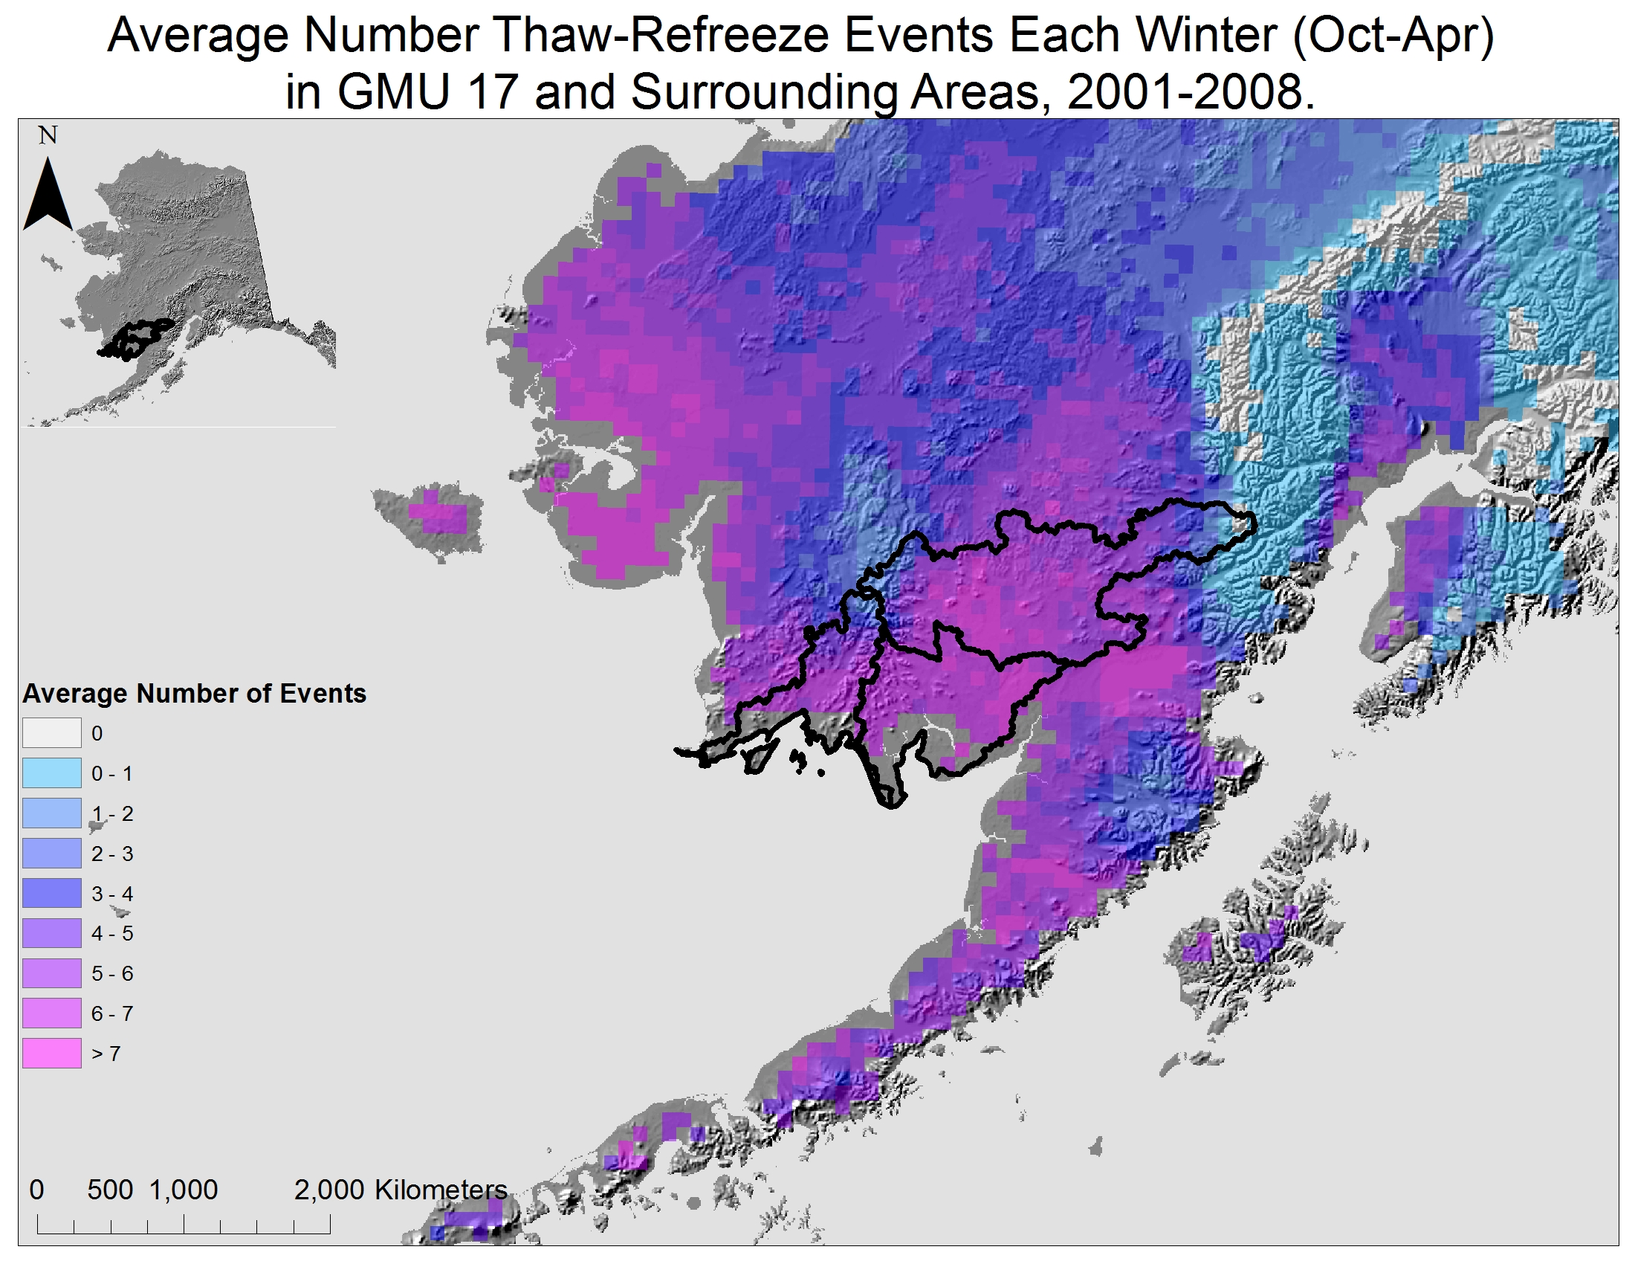

Figure 1.
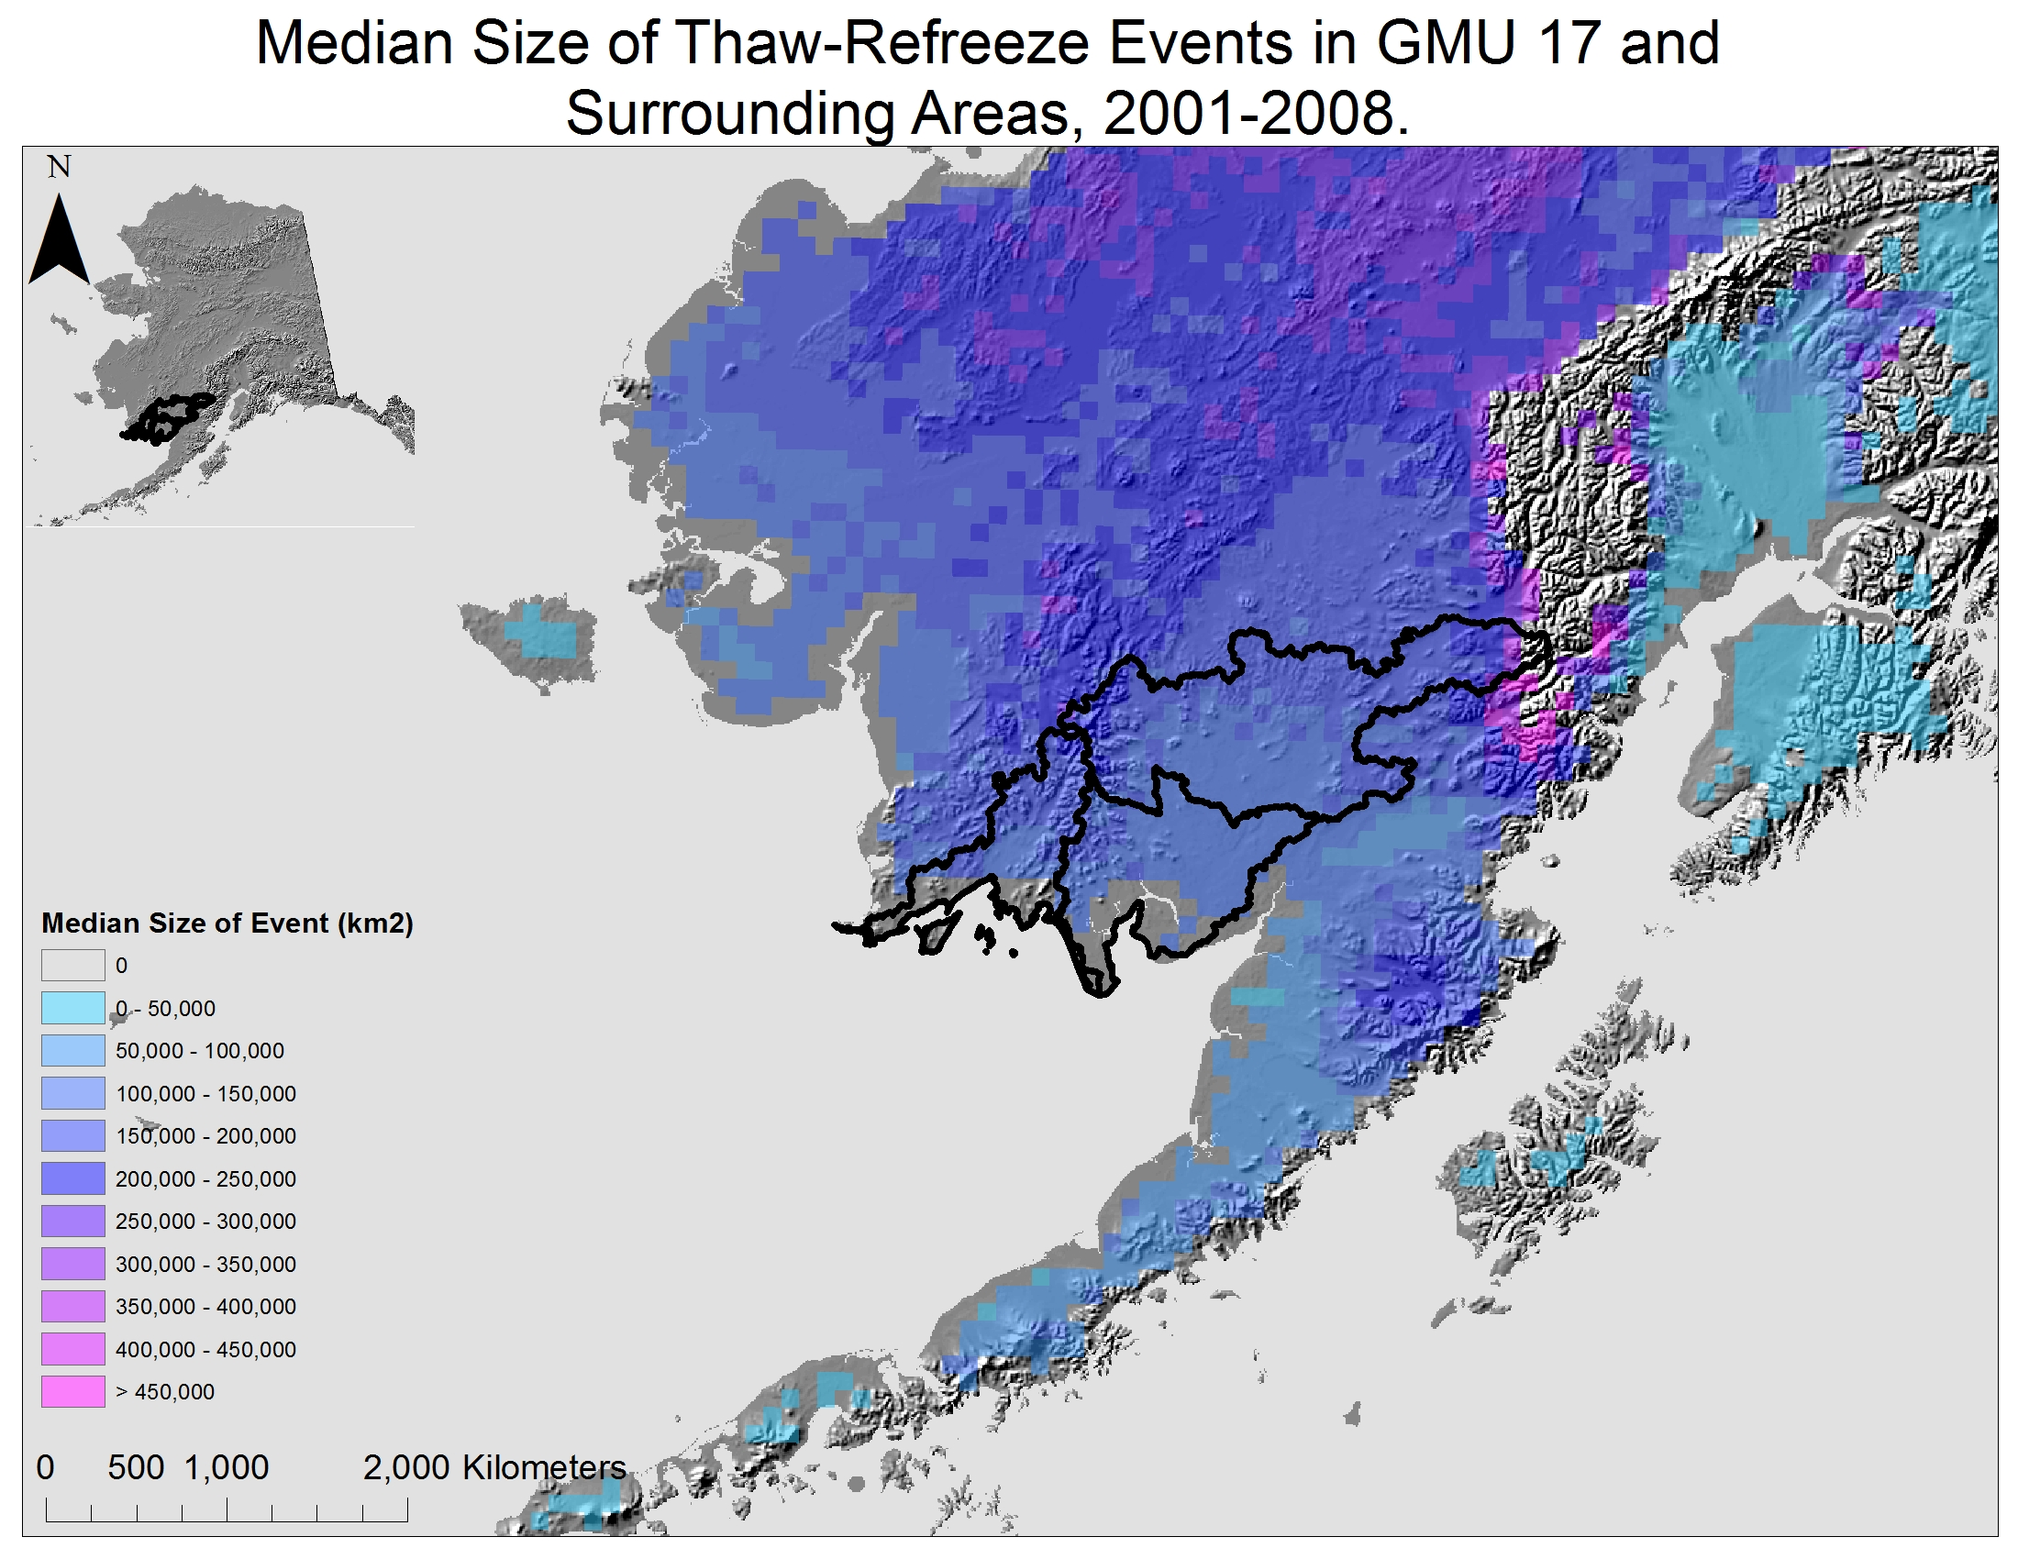

Figure 2.

The Wilderness Society, Anchorage, AK
Institute of Photogrammetry and Remote Sensing, Vienna University of Technology, Vienna, Austria
National Park Service, Fairbanks, AK
Western Alaska Landscape Conservation Cooperative, Anchorage, AK
Selawik National Wildlife Refuge, Kotzebue, AK

